FROM WATER TO WAVES PRE TEST

- What is the horizontal distance, either between the crests or troughs of two consecutive waves?
  - Wave period
  - Wavelength
  - Wave height
  - Duration

- Fetch is the length of time a single gust of wind blows across the water.
  - True
  - False

- The trough is the lowest point between two waves.
  - True
  - False

- Water has a high surface tension
  - True
  - False

- Sea water is slightly more basic (the pH value is higher) than most
natural fresh water.
  - True
  - False

- Which process involves the movement of sediment?
  - Weathering
  - Erosion
  - Freezing
  - Thawing

- Which agent of erosion creates the canyon shown in the picture?

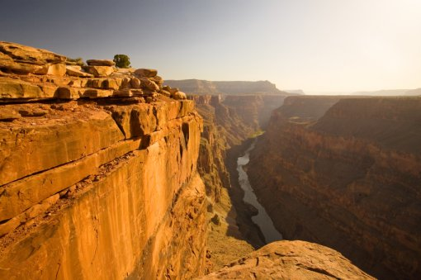
- Glaciers
- Water
- Sediment
- Landslides

ANSWER KEY
1. B
2. B
3. A
4. A
5. B
6. B
7. B

